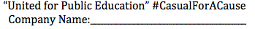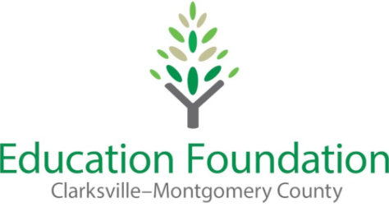
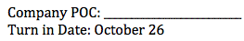
 | Employee Last Name | Employee First Name | Department | Shirt Size(s) | Quantity | Payment Method (check/cash) | Total Amount Paid
1.
2.
3.
4.
5.
6.
7.
8.
9.
10.
11.
12.
13.
14.
15.
16.
17.
18.
19.
20.
21.
22.
23.
24.
25.
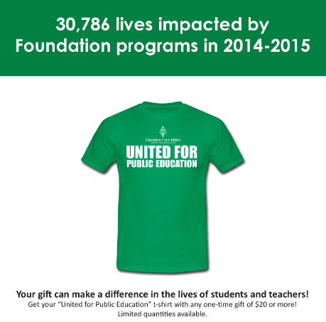
Please wear your shirts during American Education Week, November 16-20!

For more information, visit our website: cmceducationfoundation.com or email us at payton.baggett@cmcss.net.

